Investigation
Modelling is the process of representing a model which is based on a system in the real world e.g. a traffic light system whilst simulation is the process of operating the model to do study, analyse and predict the behaviour of the real-world systems. Modelling and simulation can be used anywhere from businesses tracking stocks, the military planning missions and healthcare to see how new medicine can interact with a body. I have thought about making a model based on physics and Newton’s law of universal gravitation but there are many simulations like this out there such as APlusPhysics, PhET Interactive Simulations and Labster. I have then decided to make a mountain climbing simulation as there is nothing like this out there. I chose this model idea because I used to do rock climbing, and I have always been interested in Mt Everest.

Plan and Design
I plan on using agent-based modelling to simulate climbers who all would have a random assortment of equipment, the more equipment they have, the more likely they would succeed, and a weather agent that can either improve or decrease the odds of the climbers reaching the summit with wind speeds, weather conditions and random events such as hurricanes, storms and blizzards. The programme will heavily prioritize using probability to simulate different scenarios representing the weather the climbers will have to face to reach the summit. The results will be shown in the terminal and in a pie chart.
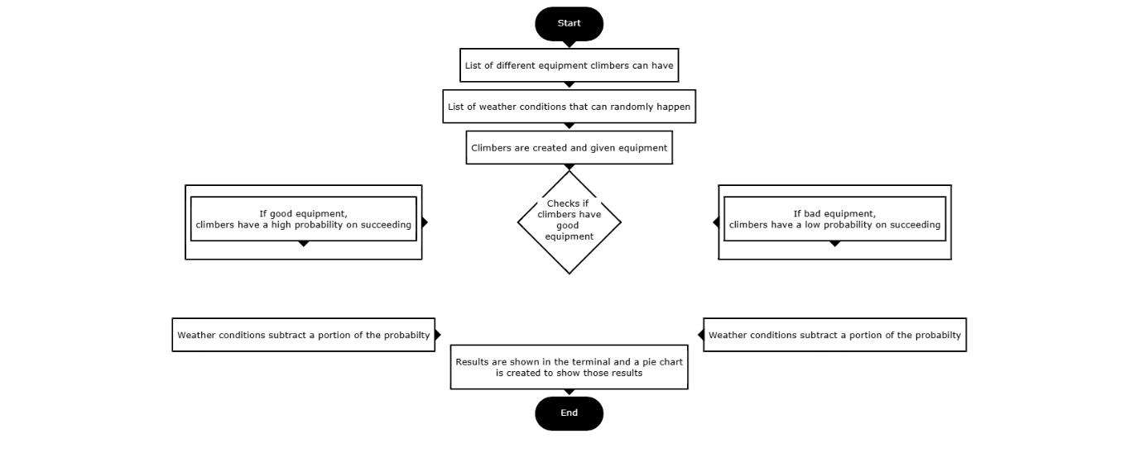

Create
I started the coding segment by creating an agent that would represent a climber with the parameters, ‘age’, ‘equipment’ and ‘rations’ that would all effect the probability of the climber reaching the top of the mountain. In a separate file, I made a weather agent where the events and weather would have their own separate parameters but when I was working with the main file ‘MT_Everest’, I had trouble implementing the parameters, so I removed the weather agent and moved the events and weather parameters into the climber agent and changed the ‘info’ function to include the events and weather.
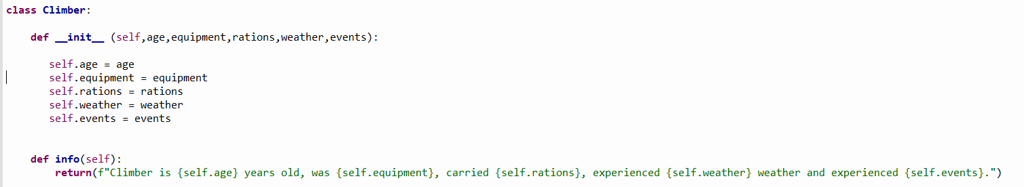
In the main file, I made 4 functions that would be called upon by the main function, ‘simulate_climbers’. The first function is ‘choose_event’ where a random number is chosen and if it is in a certain range, different events can happen, and give a penalty in a different function, but it is highly unlikely to happen. There’s another penalty function for the weather, both the events penalty and the weather penalty deduct a portion of the probability given by the ‘base_probability’ function which consist of many ifs and elifs which can assign each combination of rations and equipment to a certain probability of reaching the summit, this was a better approach than checking if the climber had good equipment and good rations. A dictionary would’ve saved more lines and been easier to access but I have not used dictionaries enough to use them in this project confidently.
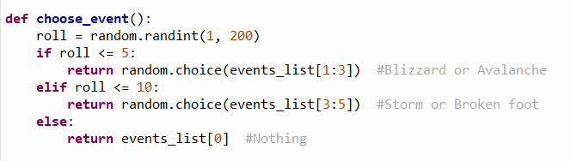
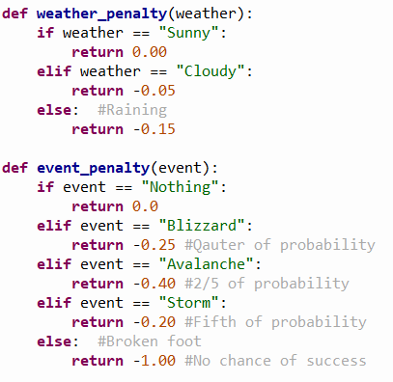
The main function of the programme uses the four previously mentioned functions and starts a list for all the climbers and all the successful climbers with a failure count and a success count. Each climber created by the function is randomly given attributes which tells them how well equipped they are, how much rations they have, what weather they will experience and what event they will experience. A lot of combinations of the climber and the penalties would cause the probability to go into the negatives, which could’ve potentially cause problems for creating the charts later, so I added 2 lines of code to force all the negative chances to turn to 0.
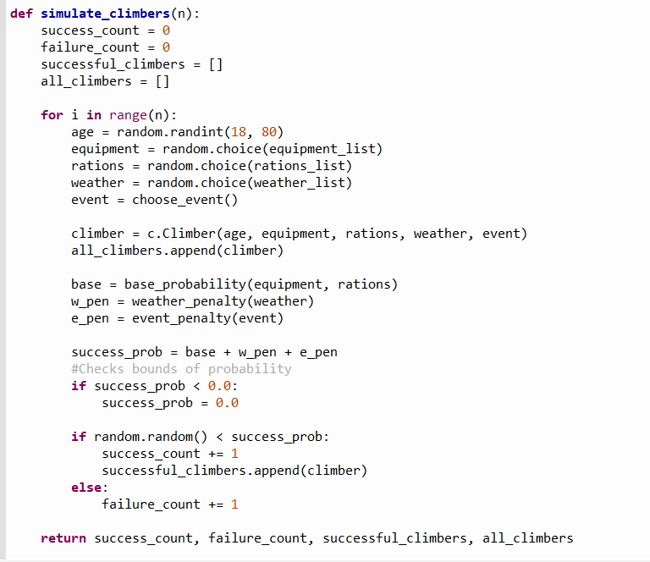
After the function is finished, I print all the successful climbers and their statistics with the ‘info’ function. I then create lists that stores what attributes each climber had for later use for charts. I had to create lists with empty slots that would be added to later because my computer would lag to much by appending each value.
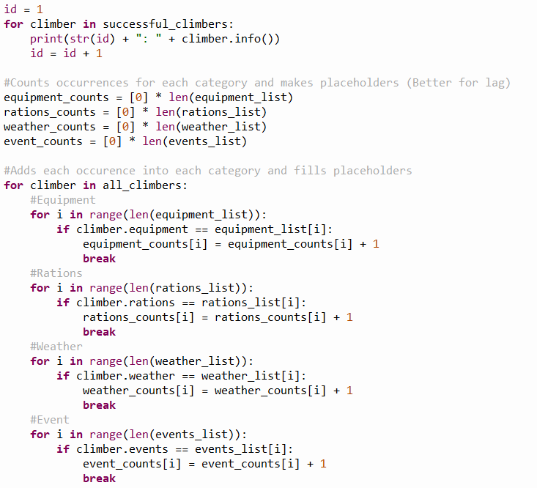

Evaluation
After running the simulation for a thousand climbers 10 times, the average success rate was 39.98%. From the bar charts, the equipment, rations and weather have all averaged out for all climbers with the values being around 250, 250 and 333 respectively. The events bar chart was the only one that was disproportional with the no event, nothing, being consistently affecting over 900 of the climbers. I could’ve added a distance-based system where every kilometre a climber climbs, the weather can change, or new events can arise affecting the probability of the climbers’ success. I added an age factor to the agent, but it didn’t affect the probability in any way, but I wasn’t sure how to add a feature that would implement the age. It would’ve been useful to add charts that showed what each attribute climber had when they reached the top instead of printing everything in the shell. I liked how well the pie chart, and the bar charts came out and how well I coded all the probabilities. Towards the end of the coding, I played around with the probabilities to see how drastically the results would change, for example, I increased the probability of how often an event could arise and it decreased the success rate to an average of 23%. With the simulation being entirely based on probabilities that I have hard coded into the programme, I first believed no emergent behaviours could be found, but once I started looking at the statistics, emergent behaviours did arise as the agent and the environment interacted with each other. The climbers who were unlucky being given bad equipment or experienced events were very unlikely to reach the top which contributed to an over 60% fail rate.

References
APlusPhysics, physics simulator -https://aplusphysics.com/educators/simulations/gravity.html
PHeT physics simulator - https://phet.colorado.edu/en/simulations/gravity-force-lab
Labster simulator - https://www.labster.com/simulations/newtons-law-of-universal-gravitation-the-mathematical-expression-of-the-gravitational-force
Flowchart maker - https://www.101computing.net/flowchart-creator/

